Project Report
(Submitted for the Degree of B.Com Honours in Accounting & Finance under the University of Calcutta)

CORPORATE SOCIAL RESPONSIBILITY: A case study on reliance company
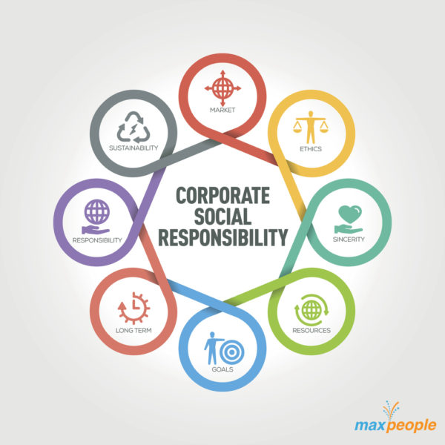
(Submitted for the Degree of B.Com Honours in Accounting & Finance under the University of Calcutta)
SUBMITTED BY
NAME OF THE CANDIDATE: LUCKY RANI SHAW
SECTION: B.COM HONOURS
CU REGISTRATION NO: 144-1211-0779-20
CU ROLL.NO: 201144-11-0082
COLLEGE ROLL NO: BH0338

SUPERVISED BY
NAME OF THE SUPERVISIOR: DR. MOUMITA SARKAR (SAMANTA)
NAME OF THE COLLEGE: BANGABASI MORNING COLLEGE

MONTH AND YEAR OF SUBMISSION: MAY 2023

ANNEXURE- I
SUPERVISOR’S CERTIFICATE

This is to certify that Lucky Rani Shaw a student of B.com 6TH semester Honours in Accounting & Finance of Bangabasi Morning College under University of Calcutta has worked under my supervision and guidance for the CORPORATE SOCIAL RESPONSIBILITY: A CASE STUDY ON RELIANCE COMPANY which she is submitting. Her Genuine and original work to the best of my knowledge.

Place : Kolkata
Date :

Signature:

Name: Dr. MOUMITA SARKAR (SAMANTA)
Designation: Assistant Professor
Name of College: Bangabasi Morning College
ANNEXURE- II
STUDENT DECLARATION

I hereby declare that this project CORPORATE SOCIAL RESPONSIBILITY: A CASE STUDY ON RELIANCE COMPANY submitted by me for the partial fulfillment of the degree B.Com Honours in accounting and finance under University of Calcutta is my original work and has not been submitted earlier under any other University or institution for fulfillment the requirement of other course of study.
I also declared that no chapter of this manuscript or part has been incorporated in this report from any earlier work done by others or by me.
However, extracts of any literature which has been used for this report has been duly acknowledge providing details of search literature in this reference.

Place: KOLKATA
Date :

Signature:
Name: Lucky Rani Shaw
CU. Reg. No: 144-1211-0779-20
CU. Roll. No: 201144-11-0082
College Roll No: BH0338

ACKNOWLEDGEMENT

I would like to thank University of Calcutta for providing with such a wonderful opportunity to prepare the project by including this as part of our study curriculum. I am very grateful to my college and my principal. I am also very thankful to my supervisor Dr. MOUMITA SARKAR (SAMANTA) for his valuable and timely guidance throughout the project. Her feedbacks, guidance and support have been very useful. I would thank him for being my mentor in doing this project. This project has allowed me a practical exposure in the corporate field and a brief introduction in the day to day working of an organisation.
Last but not the least I would like to thank my parents and friends for their support and guidance.

TABLE OF CONTENTS / INDEX

Chapters | Topics | Page No.
 | Supervisor’s Certificate | 2
 | Student’s Declaration | 3
 | Acknowledgement | 4
CHAPTER – 1 INTRODUCTION | 1.1. Background | 6-10
 | 1.2.Need of CSR
 | 1.3.Literature review
 | 1.4.Objective of the Study
 | 1.5.Methodology
 | 1.6.Limitation of CSR
CHAPTER-2 CONCEPTUAL FRAMEWORK | 2.1. Meaning Of CSR | 11-14
 | 2.2. Advantages Of CSR
 | 2.3. Disadvantages Of CSR
2.4. CSR An Integral Part of Doing
Business
CHAPTER-3 INTERNATIONAL AND  NATIONAL SCENARIO | 3.1. International Scenario Of CSR | 15-18
 | 3.2. National Scenario Of CSR
CHAPTER-4  PRESENTATION, ANALYSIS AND FINDINGS OF DATA | 4.1. Profile of Reliance Limited | 19-29
 | 4.2. Objective Of Reliance Ltd
 | 4.3. Major Subsidiaries:
 | 4.4. Strategies of Reliance:
 | 4.5. CSR Practices Of Reliance Ltd:
CHAPTER-5  CONCLUSION AND RECOMMENDATION | 5.1 CONCLUSION | 30-31
 | 5.2. RECOMMENDATION
CHAPTER-6 BIBLIOGRAPHY | BIBLIOGRAPHY | 31

CHAPTER – 1 INTRODUCTION

Background Of Study:

Corporate social responsibility defines as a company’s verifiable commitment to operating in an economically, socially and environmentally sustainable manner that is transparent and increasingly satisfying to its stakeholder. Stakeholder includes investors, customers, employees, business partners, local communities the environments and societies. CSR emphasis on transparent and verifiable stakeholder driven sustainable development business operation.¹

In recent times, the issue of corporate social responsibility (CSR) has been given a lot of attention by both Dutch business and various stakeholders. Since the advisory report of the Social Economics Rad (“Social Economic Council”, advisory board to the Dutch government) “De Winst van Warden” (“The Profit of Values”) it is broadly acknowledged among government, business and stakeholders in the Netherlands, that CSR is not about charity, but that it belongs to the core business of a company and therefore should be an integral part of doing business. Companies are under increasing pressure from society to take their social responsibility. This is especially so if it concerns companies with a business relation in a developing country, since these companies are more confronted with CSR issues.
CSR is a container concept which encompasses many different ecological, social and economic issues. In order to give a more specific interpretation to the concept of CSR a platform of Dutch NGOs has composed a so-called CSR Frame of Reference. Aim of this framework is to give companies a coherent overview of what NGOs define as CSR. The Frame of Reference is mainly based on international treaties, guidelines and instruments enjoying broad international support that are relevant for business, such as human rights, labor rights, environmental protection, consumer protection, socio-economic development, corruption and other aspects of CSR. It also includes some fundamental operational aspects of CSR like supply chain responsibility, stakeholder involvement, transparency and reporting and independent verification.

Need of CSR

    - One of the easiest places for a company to start engaging in sustainability is to use it as a way to cut the cost.
    - Brand differentiation was one of the primary reasons companies embraced CSR.
    - It can often be an easier way to talk to your customers. This is an underused tool for business-to- business company communication.
    - Attracts, retain and maintain a happy workforce and be an Employer of choice.
    - Save money on energy and operating costs and manage risk.

Literature review

Low (1985) used descriptive statistics on annual reports of 80 listed companies in Singapore, to find that though the level of corporate disclosure did not depend upon industry but higher levels of social

disclosures were found by award winning companies. Gary and Gray (1988) concluded that corporate social responsibility is a part of value added statements (VAS) and shall promote cooperation among various stakeholders though there is some ambiguity regarding the inclusion of some parties as genuine stakeholders.
Andrew et al (1989) used descriptive statistics to confirm the earlier findings that HR is the most disclosed theme followed by product, community and lastly by environment. The study also found 15 that medium to large companies made more social disclosures. These disclosures were mainly declarative and no enough evidence could be gathered to confirm or refute the association between industry and corporate social reporting.
Guthrie and Parker (1989) conducted a longitudinal study covering 100 years to relate corporate social reporting with the needs of the corporations to legalize their actions. In his research the legitimacy theory has been rejected taking six thematic disclosures namely environment, energy, human resources, product, community development and others. The thematic disclosures were measure on the basis of space incidence.
Savage (1994) reported that out of 115 South African companies approximately 50 percent of
Companies are making social disclosures with human resource (89 percent) as the main theme. Human resource disclosures related to pay, working conditions, compensation and equal opportunities. Other social disclosures include community involvement (72 percent) and environmental disclosures (63 percent).
Gray et al (1996) attempted to explain the disclosure of social and environmental information in the annual reports of large companies by reference to observable characteristics of those companies. An extensive literature has sought to establish whether variables such as corporate size, profit and industry segments can explain corporations' disclosure practices. The results from these studies predominantly North American and Australasian literature are largely inconclusive. This paper provided an extension of literature by considering a more disaggregated specification of social and environmental disclosure and by employing a detailed time-series data set. By so doing, the paper tested two possible explanations for the inconclusiveness of prior research: namely that any relationships between corporate characteristics and disclosure are dependent upon the type of disclosure and that any such relationships are not stable through time.
Hacks ton and Milne (1996) established that both size and industry are significantly associated with amount of corporate social disclosure, where as such an association could not be proved with profitability. In addition, the results indicated that the size-disclosure relationship is much stronger for the high-profile industry in New Zealand than for the lowprofile industry companies.Teoh (1998) attempted to find the association between Environmental disclosure and economic performance. T- Test was conducted on polluting or potentially polluting companies to find that significant association between environmental performance and economic performance.

Tsang (1998) concluded a longitudinal study in the banking, food and beverages, and hotel industries from 1986-1995 saying that of the 33 companies only 17 companies disclosed corporate social reporting information. Thematic emphasis analysis showed most disclosed theme is HR followed by community involvement, environment and others. The legitimacy theory was asserted to be the 16 reason for corporate social reporting. Paired difference t tests were conducted to see whether there was any difference among the three industries. The banks disclosed significantly less social information than the hotels but disclosures of the other two pairs of industries were not significantly different.
Douglas and Christopher (1999) in their study emphasized the need for environmental reporting standards to avoid confounding comparability and verification by external parties for reliability. The environmental reports issued in hard copies and on websites were mercifully diverse.
Belal (1999) reported that out of the companies selected, maximum number of companies made disclosure on employees, marginally followed by disclosure on some environmental and lastly on some ethical issues in Bangladesh.
Kilcullen and Koolstra (1999) focused on changing role of business ethics and CSR. They found that CSR has taken hold as a movement and though some organizations still indulge in unethical behavior but many more firms take social responsibility towards their stakeholders. Purushotahman, et al (2000) focused on corporate social reporting in Singapore, taking five themes such as environment, human resources, energy, community involvement and products and services. The study concluded by presenting a relationship between size of the company and CSRD. The relationship was doubtful regarding industry and corporate social reporting. The economically better performing companies were found to be more inclined towards corporate social reporting. It also asserted the fact that human resources was the most disclosed theme and that award winning companies were following more corporate social reporting practices.
Jeffery and Unerman (2000) deliberated upon the documents that need to be scanned for corporate social reporting and methods used for measurement of the quantum of the corporate social reporting. They warned that the studies solely based upon the content analysis of annual reports is certainly going to present an incomplete and misleading picture of corporate social reporting for a lot of information on social and environmental projects existed in documents other than annual reports. About the technique of measurement, the study concluded that use of sentences for measuring the volume of CSD in comparison to words or proportions of pages shall

ensure greater accuracy at the cost of reduction in relevance of study. The study also suggested inclusion of pictures, graphs, even blank spaces to reach at more relevant results measuring volume of CSD.
Belal (2001)2 pointed towards lack of adequate research in corporate social responsibility disclosures been in the context of developing countries. This study reported the results of a survey of CSR practices in Bangladesh. In addition to measuring the extent and volume of disclosures by using content analysis, it explored the socio-political and economic context in which these disclosures take place.

Objective of the study

    - To get an overview about a CSR practice by Reliance Company.
    - Discuss about new methods adopting by Reliance Company.
    - Now, Reliance Company has come down with their e-Choupal project to help the farmers.
    - Reliance Company has a wide range of product in FMCG sector, covering almost every needs and wants of the customers.
•

Methodology
The study based on secondary data .The secondary data has been collected from various books, journals, reports, articles and websites. This study is basically empirical in nature.

Limitation of CSR

- The project of CSR based on secondary data.

- It is fully depend on websites.

- I did not get any exact figure during data collection.

- I did not get much time on research of this project

Chapter planning

Chapter 1 :- Introduction
- Background of Study
- Literature review
- Objective of study
- Research Methodology
- Limitations of study
Chapter 2 :- Conceptual Framework
- Concept of Ration Analysis
- National Scenario
- International Scenario
Chapter 3 :- Presentation and Analysis of Data
- Research Methodology
- Analysis of Findings
Chapter 4 :- Conclusion and Recommendation
- Summary & Suggestions

CHAPTER-2 CONCEPTUAL FRAMEWORK

Meaning of CSR

Corporate social responsibility, often abbreviated "CSR," is a corporation's initiatives to assess and take responsibility for the company's effects on environmental and social wellbeing. The term generally applies to efforts that go beyond what may be required by regulators or environmental protection groups.

CSR may also be referred to as "corporate citizenship" and can involve incurring shortterm costs that do not provide an immediate financial benefit to the company, but instead promote positive social and environmental change.

Advantages of CSR

    - Solving social problem for ex- Is the protest against aerosol sprays.

    - Resources given by the organization to solve the social problems

    - It helps to improve stock price.

    - Best interest of business to promote and improve the communities.

    - Pressure of consumer movement to protect consumer against business malpractices like adulteration, black marketing, unfairpricing, shortage in weight measure etc. f) It attracts and retained staffs.
- It attracts investors.

- It helps to cut your business cost.

- Role in transfer of technology (TOT).

Disadvantages of CSR

Shift from the Profit-Making Objective
Milton Friedman, an economist, is the biggest critic of CSR. He says that CSR shifts the focus of the company from the objective that made it a financial entity in the first place – profit making.

The company forgets about its obligations towards its shareholders that they have to make profits for them. Instead of focusing on making profits, they engage in CSR programs and use up funds for community welfare.
So basically, instead of an income, the company is affecting an outflow of cash and not fulfilling its profit-making obligations.

Company Reputation takes a hit
According to CSR policies, companies have to disclose shortcomings of even their own products if they are found to violate the CSR program. For example, car manufacturing companies calling back their vehicles in large numbers when they find glitches in the model after having sold them wallops their reputation.
This creates inconvenience to the customers, and they lose trust in the manufacturer.

Customer Conviction
Initially, customers like to see the companies that they trust are engaged in social welfare programs.
They like the fact that these programs are for a good cause. Later, they grow wary
of it. If they don’t see instant results from these programs, they think that these are nothing but PR stunts. So it becomes difficult to convince customers that the results will take some time in coming and that they should continue believing in the good intentions of the company.
These attempts of convincing become fruitless day by day because some customers are impatient and have a constant desire to be appeased.

Increase in Cost of Production
More often than not, CSR programs increase the expenditure of the company. This increased expenditure is reflected in the increased prices of the product for which, ultimately, the customers have to pay.
Large corporations can absorb this increased expenditure. They may not increase their products’ prices, but small businesses have no other option but to increase their products’ prices to meet their increased expenses.

CSR AN INTEGRAL PART OF DOING BUSINESS Board
level CSR Committee:

- comprising of 3 or more directors with at least one independent director,

- Composition to be disclosed in the annual Board of Directors’ report .

Annual spending on CSR by companies:

  - Every financial year, at least 2% of the average net profits made during the 3 preceding financial years

  - Schedule VII indicates activities that can be undertaken by a company.

Responsibilities of the CSR Committee:

- Formulate and recommend a CSR Policy and amount of CSR expenditure

- Regular monitoring of the CSR initiatives

Responsibilities of the company’s Board:

- Approve and disclose CSR Policy in the annual Directors’ Report and on company website

- Ensure implementation of CSR activities as per the Policy

- Directors’ Report to specify reasons in case the specified amount is not spent CSR

CSR Applicable to all companies incorporated in India and having either of the following in any financial year:
  - Net worth of INR 500 crore or more or;
  - Turnover of INR 1000 crore or more or;
  - Net profit of INR 5 crore or more.

- Section 134 OF COMPANIES ACT, 2013-– Financial Statements, Boards' report - If a company fails to spend CSR amount, the Board shall in its report specify the reasons for not spending the amount .

- If a company contravenes the provisions of section 134, the company shall be punishable with fine which shall not be less than fifty thousand rupees but which may extend to twentyfive lakh rupees and every officer of the company who is in default shall be punishable with imprisonment for a term which

may extend to three years or with fine which shall not be less than fifty thousand rupees but which may extend to five lakh rupees, or with both.

Net profit to be calculated as per Section 198 of the Companies Act

Particulars* Amount Profits as per Profit & Loss Account XXX Credit to be provided for: Bounties and subsidies received from GovernmentXXX Credit not to be provided for: Premium/ Profit on sale of shares
Profits of Capital Nature-including profits on sale of undertakings

Profits from sale of immovable property/ fixed assets – unless undertaken (XXX)

Permissible Deductions:

Usual Working Charges- revenue expenditures, bonus or commission (XXX) Abnormal or Special Tax (XXX)
Interest on debentures, loans or advances

Compensations/ damages in virtue of legal liability, bad debts written off… (XXX)

Non- permissible deductions: Income tax paid under Income Tax Act, 1961 Loss of Capital Nature Compensations/ Damages paid voluntarily

PROFIT AS PER SECTION 8XXX

CHAPTER-3 INTERNATIONAL AND NATIONAL SCENARIO

INTERNATIONAL SCENARIO OF CSR
International law clearly delineates that companies have human rights responsibilities, although some of the specific responsibilities are ambiguous. The universal declaration of human rights calls upon all organs of society, whether civic groups, corporation, or government, to protect and promote human rights

In 2000, the OECD guideline for multinational enterprises were amended, passed by member states, which are committed to promote them at a national level

    - UNITED KINGDOM
The objective was to ensure that UK business take into account their economic, social and environmental impacts, and address the key sustainable development challenges based on their core competencies wherever they operate locally, regionally and internationally.

      - Strategy for advancing their vision is to :
      - Promote business activities that brings economic, social and environmental benefits
      - Work in partnership with the private sector, community bodies, and other stakeholder
      - Encourage continuing development and application of best practice
      - Ensure decent minimum levels of performance in areas such as health and safety the environment and equal opportunities

EUROPE
An increasing number of European companies are promoting their corporate social responsibility strategies as a response to a variety of social, environmental and economic pressure. The aim to send a signal to the various stakeholders with whom they interact; employees, shareholders, investors, consumer, public authorities and non-governmental organization (NGOs).

LATIN AMERICA
Under the general theme building competitiveness and communities, the forum’s promotion of socially responsible business practice in this area will concentration;

      - move from philanthropy to strategic social investment, by developing information and analysis for benchmarking systems, and leadership and capacity programs to improve management processes.
      - Developing ‘magnet’ projects to attract the involvement of more business in cross-sector projects of social concern.

The forum’s primary objective is no change current practice to goon practice through;

      - Networks of civil society organization
      - Evolving intermediary structure and institution
      - Providing links and partnerships with established business networks

ASIA
The notion of corporate social responsibility is not a new concept in Asia international organization, trade union, human rights organization; lobbyists and regulator have initiated a variety of action. Asian government are beginning to argue that strategic of CSR alliance between government and private sector does not only help enhance that such growth is accompanied by equitable people centered social measures

UNITED STATES OF AMERICA
In the United States, CSR trends evolved in large part through the efforts of a few visionary leaders like Rockefeller, Carnegie, ford, Hewlett and Packard. However, CSR owes its growth to regulation in the late 1960s and 1970s the USA government established regulatory agencies that shaped much to the internal CSR benchmark. OSHA (occupational safety Health administration), EEOC (equal employment opportunity commission); CPSC (consumer product safety commission) and the EPA (Environmental Protection Agency) created standards for responsible corporate business practices which have becomes thresholds for minimal internal CSR behavior.
SOURCE: www.business.gov.nl

3.2NATIONAL SCENARIO OF CSR

CSR is not new to India; companies like TATA and BIRLA have been imbibing the case for social good in their operations for decades long before CSR become a popular cause. In spite of having such life size successful examples, CSR in India is in a very nascent stage. It is still one of the least understood
initiatives in the Indian development sector. It is followed by a handful of public companies as dictated by the very basis of their existence, and by a few private companies, with international shareholding as this is the practice followed by them in their respective foreign country. Thus the situation is far from perfect as the emphasis is not on social good but rather on a policy that needs to be implement ted. A lack of understanding, inadequately trained personnel, non availability of authentic data and specific
information on the kinds of CSR activities, coverage, policy etc. further adds to the reach and
effectiveness of CSR programs. But the situation is changing. And CSR is coming out of the purview of 'doing social good' and is fast becoming a 'business necessity'. The 'business case' for C CSR is gaining ground and corporate houses are realizing that 'what is good for workers - their community,
health, and environment is also good for the business'. Corporate Social Responsibility Practices
- the survey on CSR is timely and apt. The survey is expected to facilitate formation of an alliance of CSR initiatives so that such initiatives can be further stream lined, focused and
converged to a powerful force of intervention. One of the major objectives of the survey is to bring out in open the current status of CSR thereby giving both the NGOs and the common man an understanding of the various initiatives undertaken by corporate and the role that is played by the government in the field. The survey underlines the various issues - current CSR policies,

major stakeholders - their current and future plans, geographical areas covered, role of civil society and government, challenges, recommendations etc.

SOURCE: Academia.edu.in

The Four Phases of CSR Development in India:-

The history of CSR in India has its four phases which run parallel to India's historical development and has resulted in different approaches towards CSR. However the phases are not static and the features of each phase may overlap other phases.

The First Phase
In the first phase charity and philanthropy were the main drivers of CSR. Culture, religion, family values and tradition and industrialization had an influential effect on CSR. In the pre industrialization period, which lasted till 1850, wealthy merchants shared a part of their wealth with the wider society by way of setting up temples for a

religious cause [citationneeded]. Moreover, these merchants helped the society in getting over phases of famine and epidemics by providing food from their god owns and money and thus securing an integral position in the society. [Citation needed] With the arrival of colonial rule in India from 1850s onwards, the approach towards CSR changed. The industrial families of the 19th century such as Tata, Godrej, Bajaj, Mode, Birla,and Singhania were strongly inclined towardseconomic as well as social considerations. However it has been observedthat their efforts towards social as well as industrial development were not only driven by selfless and religious motives but also influenced by caste groups and political objectives.

2. The Second Phase
In the second phase, during the independence movement, there was increased stress on Indian Industrialists to demonstrate their dedication towards the progress of the society. This was when Mahatma Gandhi introduced the notion of "trusteeship", according to which the industry leaders had to manage their wealth so as to benefit the common man. “I desire to end capitalism almost, if not quite, as much as the most advanced socialist. But our methods differ. My theory of trusteeship is no make-shift, certainly no camouflage. I am confident that it will survive all other theories. “This was Gandhi's words which highlights his argument towards his concept of "trusteeship". Gandhi's influence put pressure on various Industrialists to act towards building the nation and its socio- economic development. [4] According to Gandhi, Indian companies were supposed to be the "temples of modern India". Under his influence businesses established trusts for schools and colleges and also helped in setting up training and scientific institutions. The operations of the trusts were largely in line with Gandhi's reforms which sought to abolish untouchability, encourage empowerment of women and rural development.

The Third Phase

The third phase of CSR (1960–80) had its relation to the element of "mixed economy", emergence of Public Sector Undertakings (PSUs) and laws relating labor and environmental standards. During this period the private sector was forced to take a backseat. [Citation needed] The public sector was seen as the prime mover of development. [Citation needed] Because of the stringent legal rules and regulations surrounding the activities of the private sector, the period was described as an "era of command and control". The policy of industrial licensing, high taxes and restrictions on the private sector led to corporate malpractices. [Citation needed] This led to enactment of legislation regarding corporate governance, labor and environmental issues. PSUs were set up by the state to ensure suitable distribution of resources (wealth, food etc.) to the needy. However the public sector was effective only to a certain limited extent. This led to shift of expectation from the public to the private sector and their active involvement in the socio- economic development of the country became
absolutely necessary. [Citation needed] In 1965 Indian academicians, politicians and businessmen set up a national workshop on CSR aimed at reconciliation. [Citation needed] They emphasized upon transparency, social accountability and regular stakeholder dialogues.
In spite of such attempts the CSR failed to catch steam.

The Fourth Phase
In the fourth phase (1980 until the present) Indian companies started abandoning their traditional engagement with CSR and integrated it into a sustainable business strategy. In 1990s the first initiation towards globalization and economic liberalization were undertaken. Controls and licensing system were partly done away with which gave a boost to the economy the signs of which are very evident today. Increased growth momentum of the economy helped Indian companies grow rapidly and this made them more willing [citation needed] and able to contribute towards social cause. Globalization has transformed India into an important destination in terms of production and manufacturing bases of TNCs are concerned. As Western markets are becoming more and more concerned about and labor and environmental standards in the developing countries, Indian companies who export and produce goods for the developed world need to pay a close attention to compliance with the international standards.
SOURCE: https://digitalmarketinginstitute.com&CRS by RAJESH S. KADAKIA (2022)

CHAPTER-4 PRESENTATION, ANALYSIS AND FINDINGS OF DATA

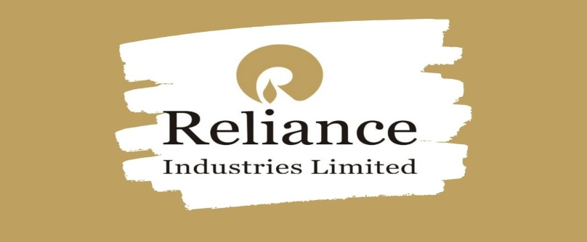

4.1 Profile of Reliance Limited:

DhiruBhai Ambani Foundation (DAF)

Dhirubhai Ambani Foundation (DAF) was established 1995 by Shri Dhirubhai Ambani. The Patron Trustee of the foundation. A public charitable trust registered under the Bombay public trusts act 1950.

DAF has for its objective a broad spectrum of worthy causes ranging from health and environment, to promotion of social and economy welfare, and ruler development. However, its main trust has been on education and public health care. DAF systematically pursues philanthropic activities to promote national welfare and social good. Reliance lends valuable support to DAF in terms of financial contribution and wherever necessary infrastructural supports. Reliance also draws on the DAF expertise in involving and coordinating the corporate social responsibility. Initiatives and other group companies also help DAF initiative wherever possible. Thus, DAF initiative reinforces Reliance’s commitment to social responsibility.

Objective Of Reliance Ltd:-
    - Understand the history of the company and its rise. An exciting story of “Rags to Riches” Understand the core business of Reliance and its subsidiary businesses.
    - A brief snapshot of the timeline
    - Strategies of Reliance, especially the oil and gas sector
    - Goals and Objectives if the business
    - SWOT Analysis
    - How Porter’s five forces affect the industry
    - Understand the strategy of backward vertical integration and how did
    - Reliance implement it to its best form
These were some of the objectives we tried to study with respect to Reliance Industries; the ADAG group was not taken into consideration when this study was undertaken. However in very recent future it does seem that both the factions of Reliance would again join hands together for business continuity. The primary objective behind this study was to understand the Reliance way

Of doing business, what was it that they did that others could not replicate to its best form. Apparently the strategies that they undertook was risky and at the same time highly rewarding. It is through the sheer brilliance of Dhirubhai Ambani that the company reached the zenith.
The domains of petrochemical, refining, and oil and gas-related operations form the core of Reliance Industry’s business. Other segments of the company include textiles, retail business, telecommunications, and special economic zone (SEZ) development. Reliance Retail has entered into the fresh foods market as Reliance Fresh. RIL is the largest publicly traded company in India by market capitalization and second- largest public corporation in India when ranked by revenue. The company is listed on Fortune Global 500 and Forbes Global 2000.In 1958 Dhirubhai started his own business in spices; he moved into textiles & opened his mill near Ahmadabad. After that Dhirubhai founded Reliance Industries.Ambani took his company (Reliance) public in 1977.By 2007 the combined fortune of the family (sons Anil & Mukesh) was 60 billion dollars making the Ambani's the second richest family in the world, next to the Walton family. Following Dhirubhai’s death in 2002, the company was split between the two sons Mukesh Ambani& Anil Ambani. Mukesh Ambani got RIL and IPCL
Reliance Industries, also owner of Mumbai Indians. Anil Ambani heads the Reliance Capital, Reliance Energy and Reliance Infocomm -Anil Dhirubhai Ambani Group (ADAG).

Major Subsidiaries:
    - Reliance Petroleum Limited
    - Reliance Netherlands BV (including Trevira)
    - Reliance Retail Limited
    - Ranger Farms Private Limited
    - Retail Concepts and Services Private Limited
    - Reliance Retail Insurance Broking Limited
    - Reliance Dairy Foods Limited
    - Reliance Retail Finance Limited
    - Reliance Jamnagar Infrastructure Limited
    - Reliance Industrial Investment & Holdings Limited
    - Reliance Ventures Limited
    - Reliance Strategic Investments Limited
    - Reliance Exploration & Production – DMCC

Indian Petrochemicals Corporation Limited (IPCL):-
IPCLwas a petrochemicals corporation in India. Set up on March 22, 1969, with a view to promote and encourage the use of plastics in India, it worked in the field of polymers, synthetic fiber, fiber intermediaries, solvents, surfactants, industrial chemicals, catalysts, adsorbents, and polyesters. The Company operates three petrochemical complexes, a naphtha based complex at Vadodara and gas based complex each at Nagothanenear Mumbai and at Dahej on Narmada estuary in bay of Khambhat. The Company also operates a catalyst manufacturing facility at Vadodara. Its turnover for the financial year 2005-06 had crossed the US $ 2 billion mark.InJune 2002, the Government of India as a part of its

disinvestment programmed vested 26% of its equity shares in favor of Reliance Petro investments Limited (RPIL), Reliance Group Company. RPIL acquired an additional 20% equity shares through a cash offer in terms of SEBI (Takeover Regulations) and currently holds 46% of Company's equity shares. This interesting information gives us an idea how Reliance dominates the market. IPCL was a highly profit making company, however, Reliance was foraying in the Industry of polyester and wanted to be the market leader, Reliance had its eyes for quite some time on IPCL, so when the opportunity came it bought out 26% stake in a divestment sale by the GoI and further also took hold of 20% equity share and thus becoming 46%, the major shareholder of the company, in the process becoming the largest polyester producing company in the country and one of the largest in the world. This is one of the primary strategies of Reliance; it waits for an opportunity to take over any leading company and then becomes a part of their rise to fame, making money in the process.

- Reliance Retail is the retail business wing of the Reliance Industries. In March 2013, it had 1466 stores in India. It is the largest retailer in India. Many brands like Reliance Fresh, Reliance Footprint, Reliance Time Out, Reliance Digital, Reliance Wellness, Reliance Trends, Reliance Kitchens, Reliance Market (Cash n Carry) and Reliance Jewel come under the Reliance Retail brand. Its annual revenue for the financial year 2012–13 was 10800 crore (US$1.7 billion) with an EBITDA of 78 crore (US $12 million).
- Reliance Life Sciences works around medical, plant and industrial biotechnology opportunities. It specializes in manufacturing, branding, and marketing Reliance Industries' products in bio- pharmaceuticals, pharmaceuticals, clinical research services, regenerative medicine, molecular medicine, novel therapeutics, biofuels, plant biotechnology, and industrial biotechnology sectors of the medical business industry. Reliance Institute of Life Sciences (RILS), established by DhirubhaiAmbaniFoundation, is an institution offering higher education in various fields of life sciences and related technologies. Reliance Logistics is a single-window company selling transportation, distribution, warehousing, logistics, and supply chainrelated products, supported by in-house telematics and telemetry solutions. Reliance Logistics is an asset based company with its own fleet and infrastructure. It provides logistics services to Reliance group companies and

outsiders. Merged content from Reliance Logistics to here. See Talk: Reliance_ Industries# Merge_ proposals.
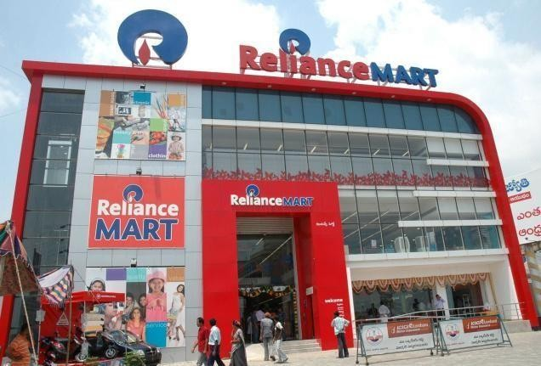

- .Reliance Clinical Research Services (RCRS), a contract research organization (CRO) and wholly owned subsidiary of Reliance Life Sciences specialize in the clinical research services industry. Its clients are primarily pharmaceutical, biotechnology and medical device companies.
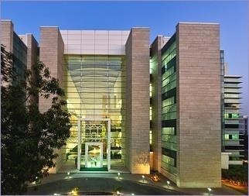

- Reliance Solar, the solar energy subsidiary of Reliance, was established to produce and retail solar energy systems primarily to remote and rural areas. It offers a range of products based on solar energy: solar lanterns, home lighting systems, street lighting systems, water purification systems, refrigeration systems and solar air conditioners.
Merged content from Reliance Solar to here. See Talk: Reliance_ Industries# Merge_ proposals. Record is a cord blood banking service owned

by Reliance Life Sciences. It was established in 2002. It has been inspected and accredited by AABB, and also has been accorded a license by Food and Drug Administration (FDA), Government of India.
- Reliance JioInfocomm (RJIL), previously known as Infotel Broadband, is a broadband service provider which gained 4G licenses for operating across India. Now it is wholly owned by RIL for 4800 crore (US $770 million).

- Reliance Industrial Infrastructure Limited (RIIL) is an associate company of RIL. RIL holds 45.43% of total shares of RIIL. [7] It was incorporated in September 1988 as ChemburPatalganga Pipelines Limited, with the main objective being to build and operate cross-country pipelines for transporting petroleum products. The company's name was subsequently changed to CPPL Limited in September 1992, and thereafter to its present name, Reliance Industrial Infrastructure Limited, in March 1994. RIIL is mainly engaged in the business of setting up and operating industrial infrastructure. The company is also engaged in related activities involving leasing and providing services connected with computer software and data processing. The company set up a 200- millimeter diameter twin pipeline system that connects the Bharat Petroleum refinery at Mahul, Maharashtra, to Reliance's petrochemical complex at Patalganga, Maharashtra. The

pipeline carries petroleum products including naphtha and kerosene. It has commissioned facilities like the supervisory control and data .
acquisition system and the cathodicprotection system, a jack well at RiverTapi, and a raw water pipeline system at Hazira. The infrastructure company constructed a 71,000 kilo- liter petrochemical product storage and distribution terminal at the Jawaharlal Nehru Port Trust (JNPT) Area in Maharashtra. [citation needed]
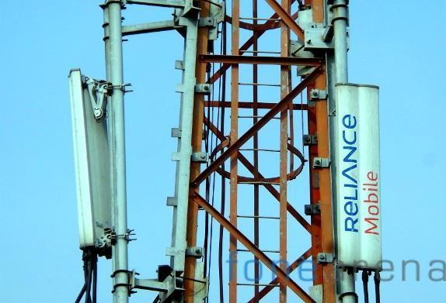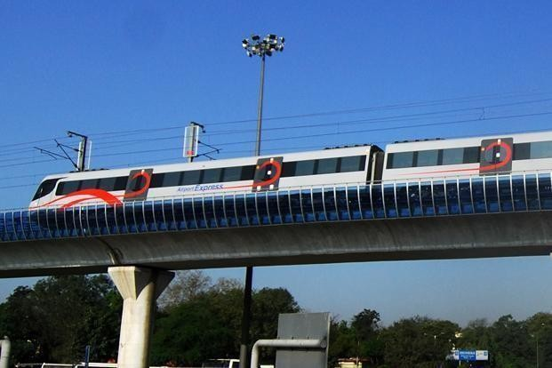

Strategies of Reliance:
    - Building and sustaining leadership position across its product categories in the domestic markets
    - Pursuing attractive export opportunities

    - Implementing backward vertical integration

    - Improving its technology

    - Achieving economies of scale

    - Focusing on prudent financial management

    - Investing in high growth opportunities.

CSR Practices Of Reliance Ltd:
SOCIAL RESPONSIBILITY & COMMUNITY DEVELOPMENT:-
Social welfare and community development is at the core of Reliance’s Corporate Social Responsibility (CSR) philosophy and continues to be a top priority for the Company. It revolves around the company’s deeply held belief in the principle of symbiotic relationship with the local communities, recognizing that

business ultimately as purpose- to serve human needs. Close and continuous interaction with the people and communities in and around the manufacturing divisions has been the key focus while striving to bring around qualitative changes and supporting the under privileged. Reliance’s contributions to the community are in the area of health, education, infrastructure development (drinking water, improving village infrastructure, construction of schools etc.), environment (effluent treatment, tree plantation, treatment of hazardous waste.), relief and assistance in the event of natural disaster and miscellaneous activities such as contribution to other social development organization etc.
The Company’s CSR team’s at all manufacturing division interacts with the neighboring community on regular basis. The company takes prided in the fact that their CSR representatives are known by their first names in the regions that it operates.

    - EDUCATION
‘Teach them young’ is the very motto of Reliance as the Company believes that the quality of inputs received by an individual at an early age contributes to his or her growth as a capable human being. To ensure high quality of teaching, Reliance has made significant efforts towards value enhancement of teachers through professional and institutionalized training. Dahej Manufacturing Division conducted educational and excursion tours of studentsteachers from primary schools of neighboring villages, and also organized ‘Balmela’ and science and mathematics fair. To provide training in the field of effective techniques and modern methods of teaching to high school teachers in the Hazira area, the company organized training of teachers in various subjects.

Reliance has launched the “Sky is the limit” programmed at Hazira, to address the problem of school drop- outs in the local community. The company also provides opportunities to engineering and management instituted students to undergo in-plant training/projects as part of their academic curriculum, thus enabling them to appreciate application of theoretical knowledge and get an exposure to the industrial practices. Efforts were made to enhance employability/scale development of local youths. This was done by giving opportunities t them to work in the company’s operating plants. Executive development programs for officers of neighboring industries were organized in co-ordination with PRIYA (patal ganga rasayani industries association). The company’s major manufacturing locations provide good quality education to the children of all employees and also cater to the needs of surroundings
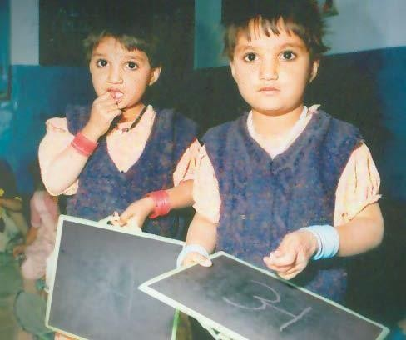

Villages.JamnabenHirachandAmbaniSchool,KokilabenDhirubhaiAmbaniVidyaMandir, and Jamnaben Hirachand Ambani Saraswati Vidya Mandir are school near the company’s manufacturing location at patalganga, hazira and jamanagar respectively. A modern educational infrastructure coupled with extra- curricular activities and recreational facilities distinguish all these school. To encourage school children from neighboring villages.
Nagothane manufacturing division based CSR cell MGCC area Development Research Foundation (MADER) Trust took following initiatives.
- Felicitated meritorious student from neighboring villages and tribal hamlets
- Each student received a set of note books, stationary items and a school bag
- There are several Zillaparishad schools located on the hilltop near Nag thane manufacturing Division where all the children who are attending school are tribal.
- With an objective to encourage the tribal students. Reliance also provided school uniforms.

COMMUNITY DEVELOPMENT
Jamnagar Manufacturing Division continues to extend a helping hand to surrounding villages and the community at large. Activities during the year focused on improving village infrastructure, supply of drinking water, education support etc. during the year, in a unique initiative to improve rural housekeeping and sanitation, a totally fresh approach was adopted to beautify Motikhavdi; Reliance’s adopted village. Cleaning and sanitation drive at Motikhavdi was taken up as an ongoing project. Three Mous were finalized with the State Government of Gujarat for development of Dwarka during the year.
They are to:-Development the temple square in front of the famous Dwarkadheesh temple.
Construct ‘Sudama Setu’ a bridge to connect both the banks of Gomati River behind Dwarkadheesh temple.

Develop ‘Panch-kui’ area on the sea-shore where five wells, believed to be dug by Pandavas, still give fresh potable water right on the seashore.

To maintain and support village cows in surrounding villages, two more brand new cowsheds for Kanalus and Kanachikari were constructed and handed over to there respective villages. These cows and cows-sheds(“Gaushala”) receive regular fodder supply from the company’s Jamnagar Manufacturing Division. Construction of a public lavatory, water tank and avedo (common drinking water facility for villagers) was done atNaniKhavdi during the year under report. Drinking water through water tankers was supply during the crisis period in Sikka, Nanikhavdi, Meghpar and Padana. At Kanachikari, drinking water pipelines were laid during the year. A new primary school building at Navagam was constructed and repairing of some village schools was taken up. Participation and distribution of sweets in village schools during the Independence Day and the Republic Day; support to Government of Gujarat’s drive for girl’s education, distribution of gifts to girls of villages during Navratri festival; supporting Navratri celebrations in Jamnagar were some of the salient aspects of Jamnagar Manufacturing Division’s community welfare cell as part of routine and regular activities. In a major initiative to celebrate Navratri, the world’s longest dance festival on a large scale; Jamnagar manufacturing division took a lead to form Gujarat Industries Navratri festival.

A gala festival was organized and celebrated at state capital Gandhinagar’s helipad ground for nine days jointly with leading industries of Gujarat. The event brought to fore the role of industries, handicraft, art and culture etc. in the development of Gujarat as a vibrant state. The event evoked tremendous response and applause from every quarter of the society at large.

SKILL UPGRADATION
Reliance runsspecial training programs to equip the young people of neighboring villages with life and work skills necessary for sustaining livelihood. Nagothane manufacturing division conducted training in fashion designing course for the ladies to upgrade the skills
of those women who are already trained in the basic tailoring. This division also conducted computer education courses and nursing assistant training courses. The trainees also received hands on training at the local hospitals and primary health centers at Nagothane. The company also trains the youth in vehicle driving courses and also helps them in getting a driver’s license so that they can earn a livelihood by starting their own business as motor drivers. The company’s Polymer business division organized technical training programs at 50 Industrial Training Institute (ITIS) all over India to enhance skills of artisans for new and advance technique of plumbing with PPR pipes. The company also offers plumbing kits, free of cost, to various plumbers as well as to IT IS to promote this new energy efficient application in the building industries. PPR pipes are faster to install than metal pipes. This results in improving daily productivity of plumbers there by increasing in their earnings. This initiative covered many plumbers across the country.

PACKAGING SOLUTION TO FARMERS {LENOBAGS}
Reliance organized extensive awareness programs on improved packaging solutions for potato and other vegetables for farmers all over India. This included demonstration on use of leno bags, which are more durable, functionally more efficient and cheaper than traditional materials. This program helped the farmers reduce the cost of packaging of potato. These bags also helped farmers to reduce wastage while keeping in cold storage.
The company’s efforts helped the farmers to improve their earnings. The program covered more than 10,000 farmers across India.

Energy Sources Polyethylene (PE) Biogas Domes for Renewable

Biogas technology for rural development has been a focus area for Government of India. Ministry of New and Renewable Energy (MNRE) promotes family type biogas plants under the National Project on Biogas Development (NPBD). The project was launched in 1981-82 with the objective of producing clean and alternate renewable energy for cooking and lighting, enriched organic manure for agriculture usage, improving sanitation and hygiene and reducing drudgery of women. The two cubic meter “Deenabhandu” model is the most popular family type fixed dome biogas plant developed with conventional brick and cement. Many of these plants get defunct due to dome cracks leading to gas leakages. The company has developed 100 per cent leak-proof root molded PE dome, which gives end- users a unique combination of properties like good strength, stiffness, light weight, seamless construction, ease of installation and very little maintenance. The PE based dome

has been developed by Reliance and has been approved by the Ministry of New and Renewable Energy, Government of India.

Eco-friendly Initiatives

In addition to the above initiatives, the company also focuses on the development of the eco-system and improvement, of the green belt across its manufacturing and E&P sites.

Reliance DhirubhaiAmbaniProtsaham Scheme:-

The Scheme, launched in AY 2008-09, continues to supportpoormeritoriousstudents. Recipient students of Reliance Dhiru Bhai Ambani Protsaham Scheme got admissions in junior colleges of their choice.Withadmissionsof AY 2010-11, the total strength of studentsreceiving support under thescheme has gone up to 656. The first batch of the Protsahan students passed out the intermediate examination held in March 2010 with flying colors and from AY 2010-11 onwards, RIL is providing financial aid to the toppers for pursuing their higher studies in engineering and medical streams.

Dhiru Bhai Ambani Hospital

Hospital atLodhivali, Maharashtra continues to play a significant role in improving the quality of life in surrounding communities. It extends prompt and specialized services to the Mumbai-Pune highway accident victims. Trauma patients are provided free lifesaving treatment. Besides taking care of hospitalization requirements, the hospital provides poor patients and senior citizens subsidized treatment
- both in the outpatient and in-patient departments. ART clinic, a public- privatepartnership initiative between RIL, CII and NACO, offers free of cost treatment to HIV/AIDs patients.
A well-equipped community medical centre with four observation bed facility at Jamnagar continues to offer free-of-cost, round the clock with comprehensive health services. Manufacturing divisions offer free medical services including free medicines to the neighboring villages. In tribal villages surrounding Nagothane Manufacturing Division, villagers are deprived of medical facilities in the region because of absence of proper approach road to the villages as they are located on hilltops. The manufacturing division realizes the health problems faced by the tribal's and it took a major step towards providing free OPD (out patient department) treatment on weekly basis to the tribal people staying at hill tops. Moreover, the manufacturing division developed the road and even made it motor able up to village Gangawane. Every week a doctor with medical team and medicines visits tribal hamlet and provides OPD services to tribals.
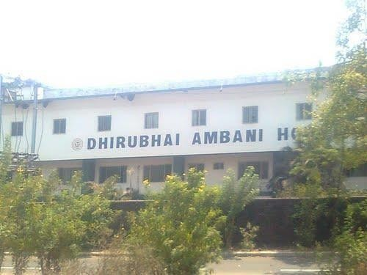

CSR PRACTICES OR RELIANCE LTD.
Vocational skill 5%
Arts and culture 15%
Education 16%
Sports 10%
Health 16%
Community development
10%
Agriculture 10%
Water 8%
Environment 10%
Sail Gail(india)
5%
L&T 6%
6%
SBI 6%

IOCL 8%
Reliance 26%
JSPL 8%
Coal India 11%
Tata and steel
13%
ONGC 11%

Figure; 1

The above pie chart shows that CSR practice of Reliance in various fields such as art and culture, education, water etc

LARGEST SPENDERS IN ABSOLUTE TERMS :

Figure; 2

The above pie chart shows that largest spender in absolute term such as Reliance, Tata Steel, and Coal IndiaET .

CHAPTER-5 CONCLUSION AND RECOMMENDATION

Conclusion

Hereby, I conclude the project of CORPORATE SOCIAL RESPONSIBILITY is titled to aid an organization mission as well as guide to what Reliance company stands for and will uphold to its consumer. I have even got so many knowledge and experience from this project.
It is concluded that CSR is about business, government and civil society collaboration with the bottom line is the achievement of win-win situation among the three entities. From the social point of view CSR should benefit community because the latter has a very complex structure as it consists of individuals with various levels of control of resources physically and intangibly. The analysis on the theories allows the understanding of CSR that goes beyond its traditional meanings. Therefore, CSR necessitates a multi-disciplinary approach in its perspective and practice. Since the current meaning of CSR is complex knowing the theories allows scholars to have a better understanding about corporation-society relations, in which theories and practices of CSR are influenced by numerous economic and non-economic as well as internal and external forces.
For many corporate leaders, it is very difficult to know where their responsibilities begin and end in relation to building infrastructure, creating economic opportunities and access to core services such as health, education and poverty alleviation. Experience has made one thing certain that sustainable CSR solutions at community, provincial and national levels are based on partnerships between government, civil society and business

Recommendation

Reasoning about the importance of engaging in CSR activities for businesses Scheck (2009) states that “although beyond compliance firm behavior might be a good indicator for socially responsible behavior, it is critical to assume that CSR starts only where the law ends “Secondary data authors also highlight the importance of source of CSR principles and policies for business.Following Recommendation for businesses in order to engage in CSR activities with an increased level of efficiency:
    - Achieving increased level of cooperation between the various department of the business in term of achieving CSR related aims and objective

    - Engagement in strategic use of social investment budget .

    - Introducing CSR aspects of the business at the initial stages of the project and integrating it with long term aims and objectives.
    - Specifying the activities of stakeholder identification and engagement as a continuous process.
    - Ensuring the existence of CSR skills in all employees within the organization.

CHAPTER-6 BIBLIOGRAPHY

There are some books and web sides’ names where I got so many information about my project that is “CORPORATE SOCIAL RESPONSIBILITY OF RELIANCE LTD.
REFERENCE BOOKS:-

- CSR : During the most good for your company and your cause, Edition-2004, professor kotller’s
- CSR Balancing Tomorrow’s sustainability and today’s profitability, Edition-2006, David E.Hawkins
- CSR and Competitiveness, Edition-2000,Rusen Kumar

- CORPORATE SOCIAL RESPONSIBILITY, Edition-2004, Andrew Crane, Dirk Matten and Laura J. Spence.

WEBSITES:-

- www.unescape.org/tid/apdf/..kehua.PDF

- www.ilo.org

- www.foundation.indiatimes.com

- www.forbes.com

- www.ibeybusinessjournal.com

- www.reliancepower.co.in

- www.ril.com/.../social-resp-cumm-dv

